EXP 12:

DOCKER:

Create a Simple Python Flask API, Containerize the Application, Build & Push the Image using Docker and Deploy the Application using Kubernetes.

Tasks: 1. Create a Simple Flask API by writing a Python file (app.py) with basic endpoints.

2. Containerize the Flask App using Dockerfile.

3. Build the Image using Docker.

4. Push the Image to Docker Hub.

5. Create Kubernetes manifests (Deployment YAML & Service YAML) to deploy the application.

6. Apply the Manifests and Access the API via NodePort.

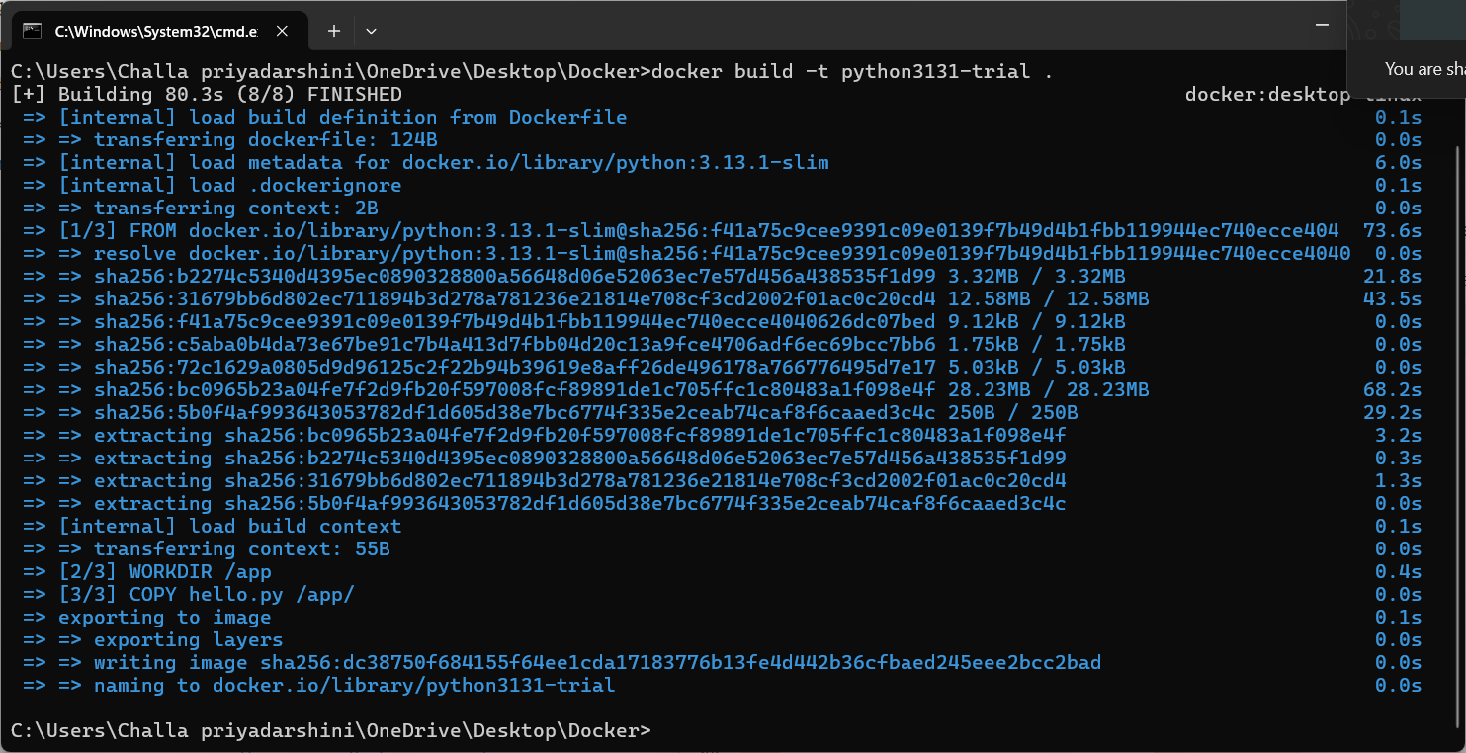

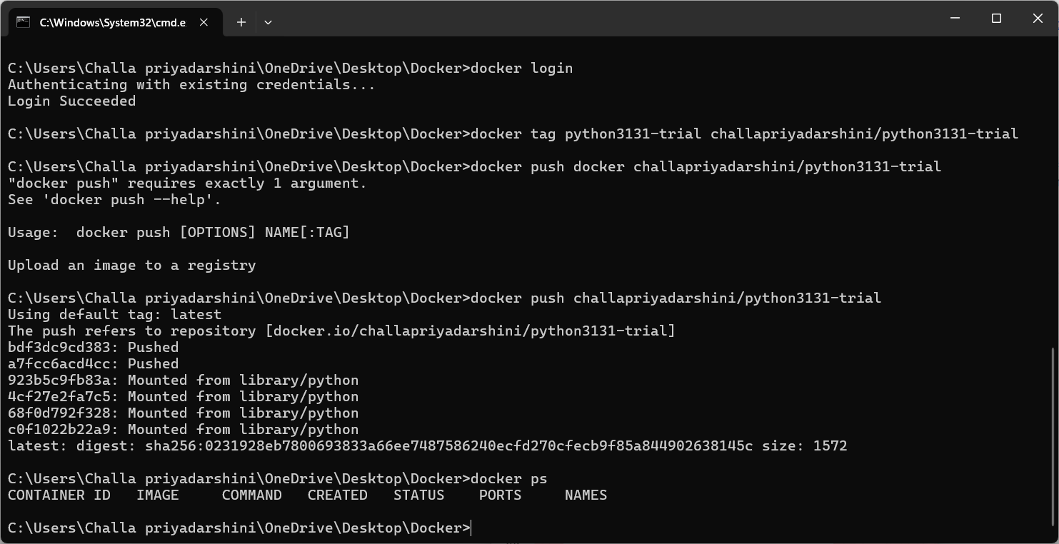

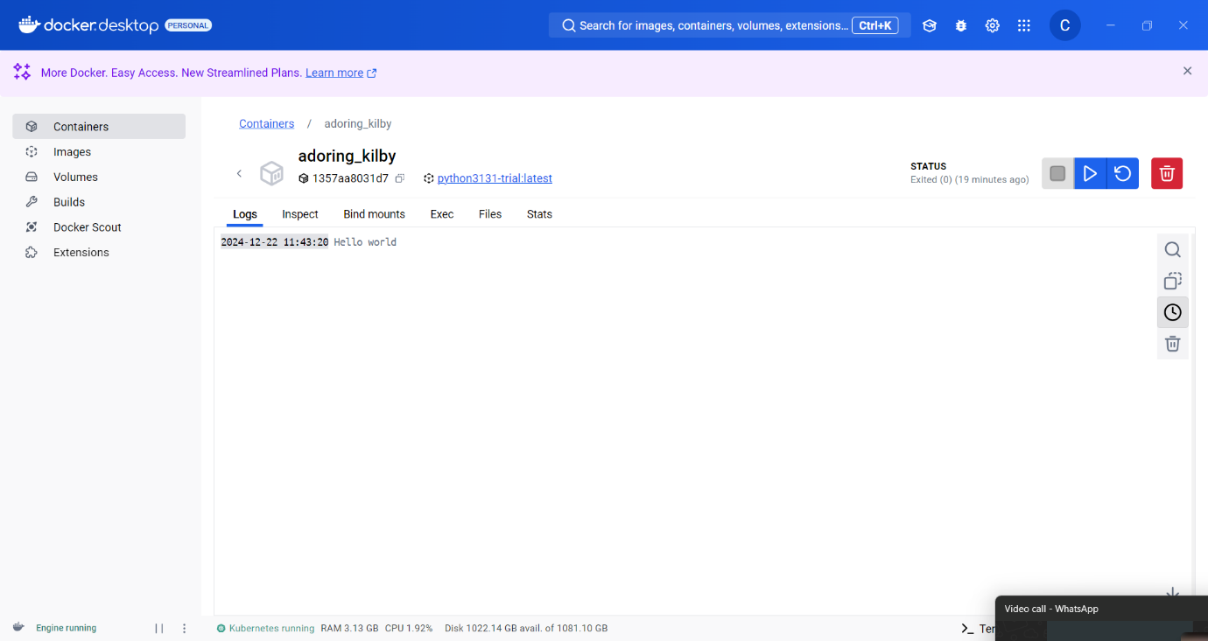

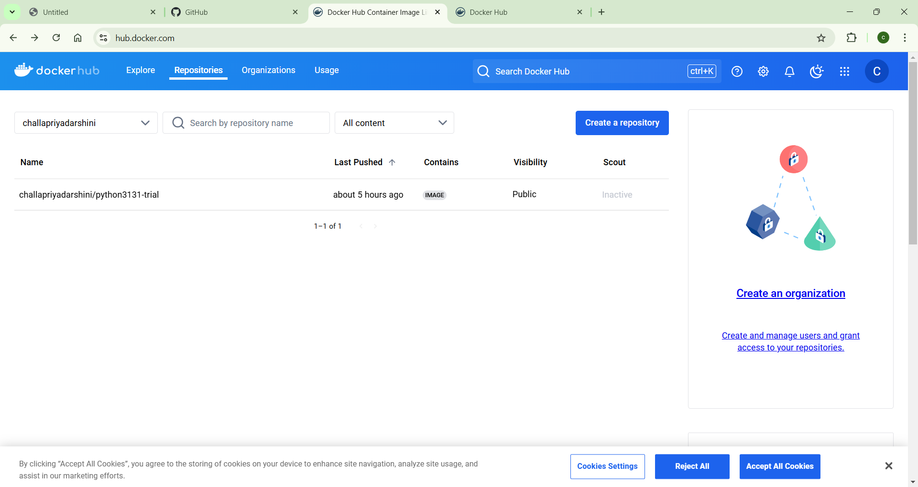

EXP 20:

GIT/GITHUB:

Create a new GitHub repository for a personal project. Initialize the repository with a README.md file. Then, clone the repository to your local machine, make some changes to the README.md (e.g., add a project description), and push the changes back to GitHub. Tasks:

• Create a GitHub repository.

• Clone the repository to your local machine.

• Edit the README.md file.

• Stage, commit, and push your changes to GitHub.

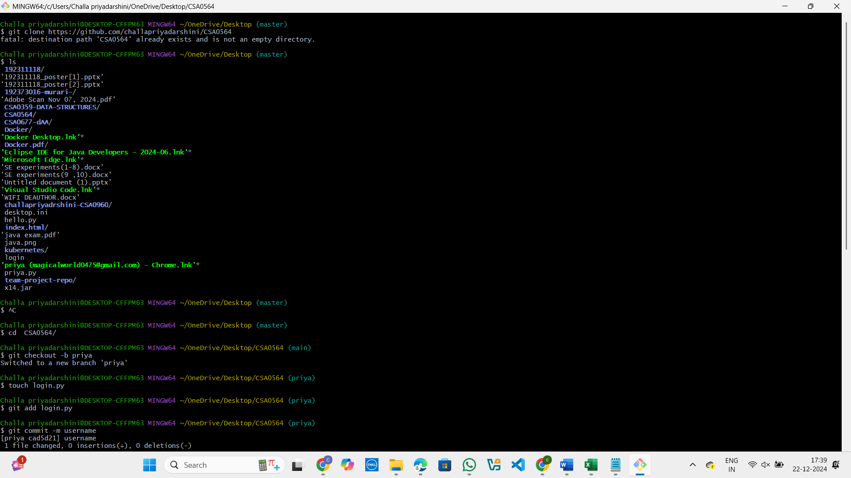

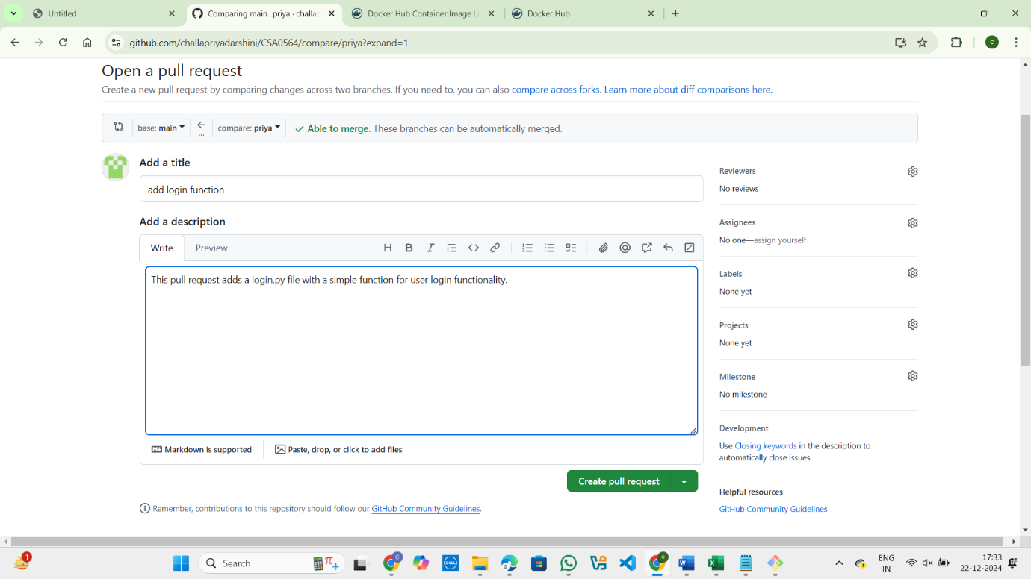

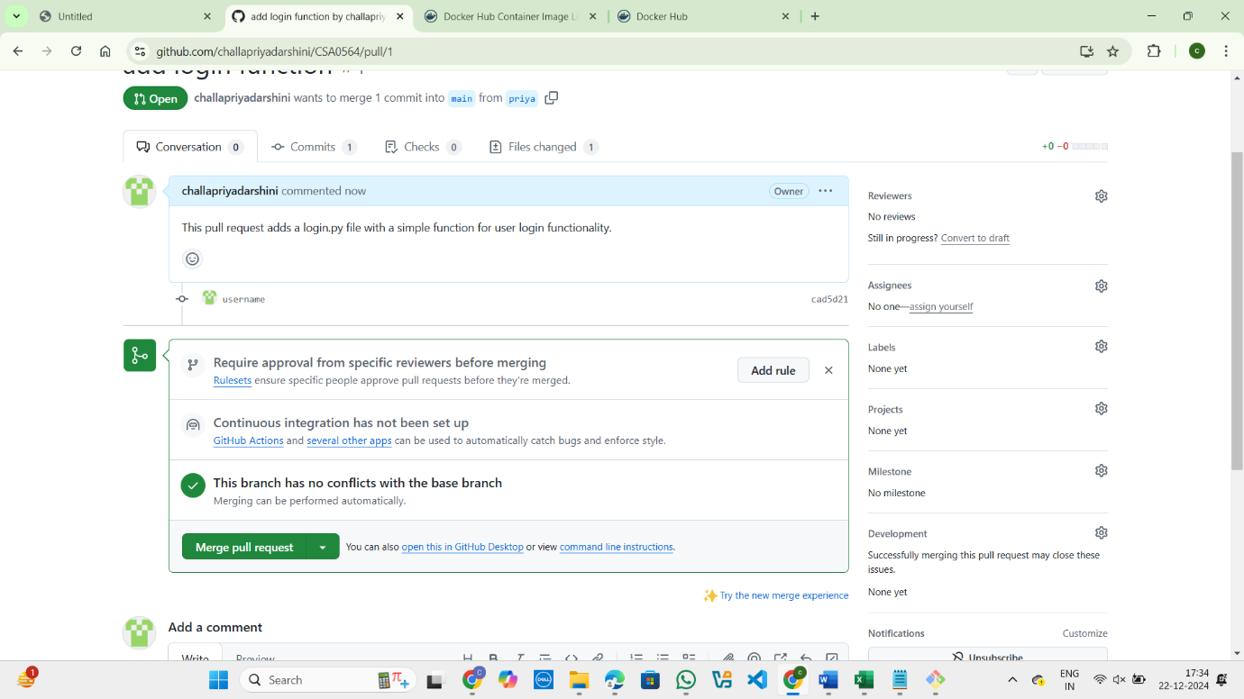

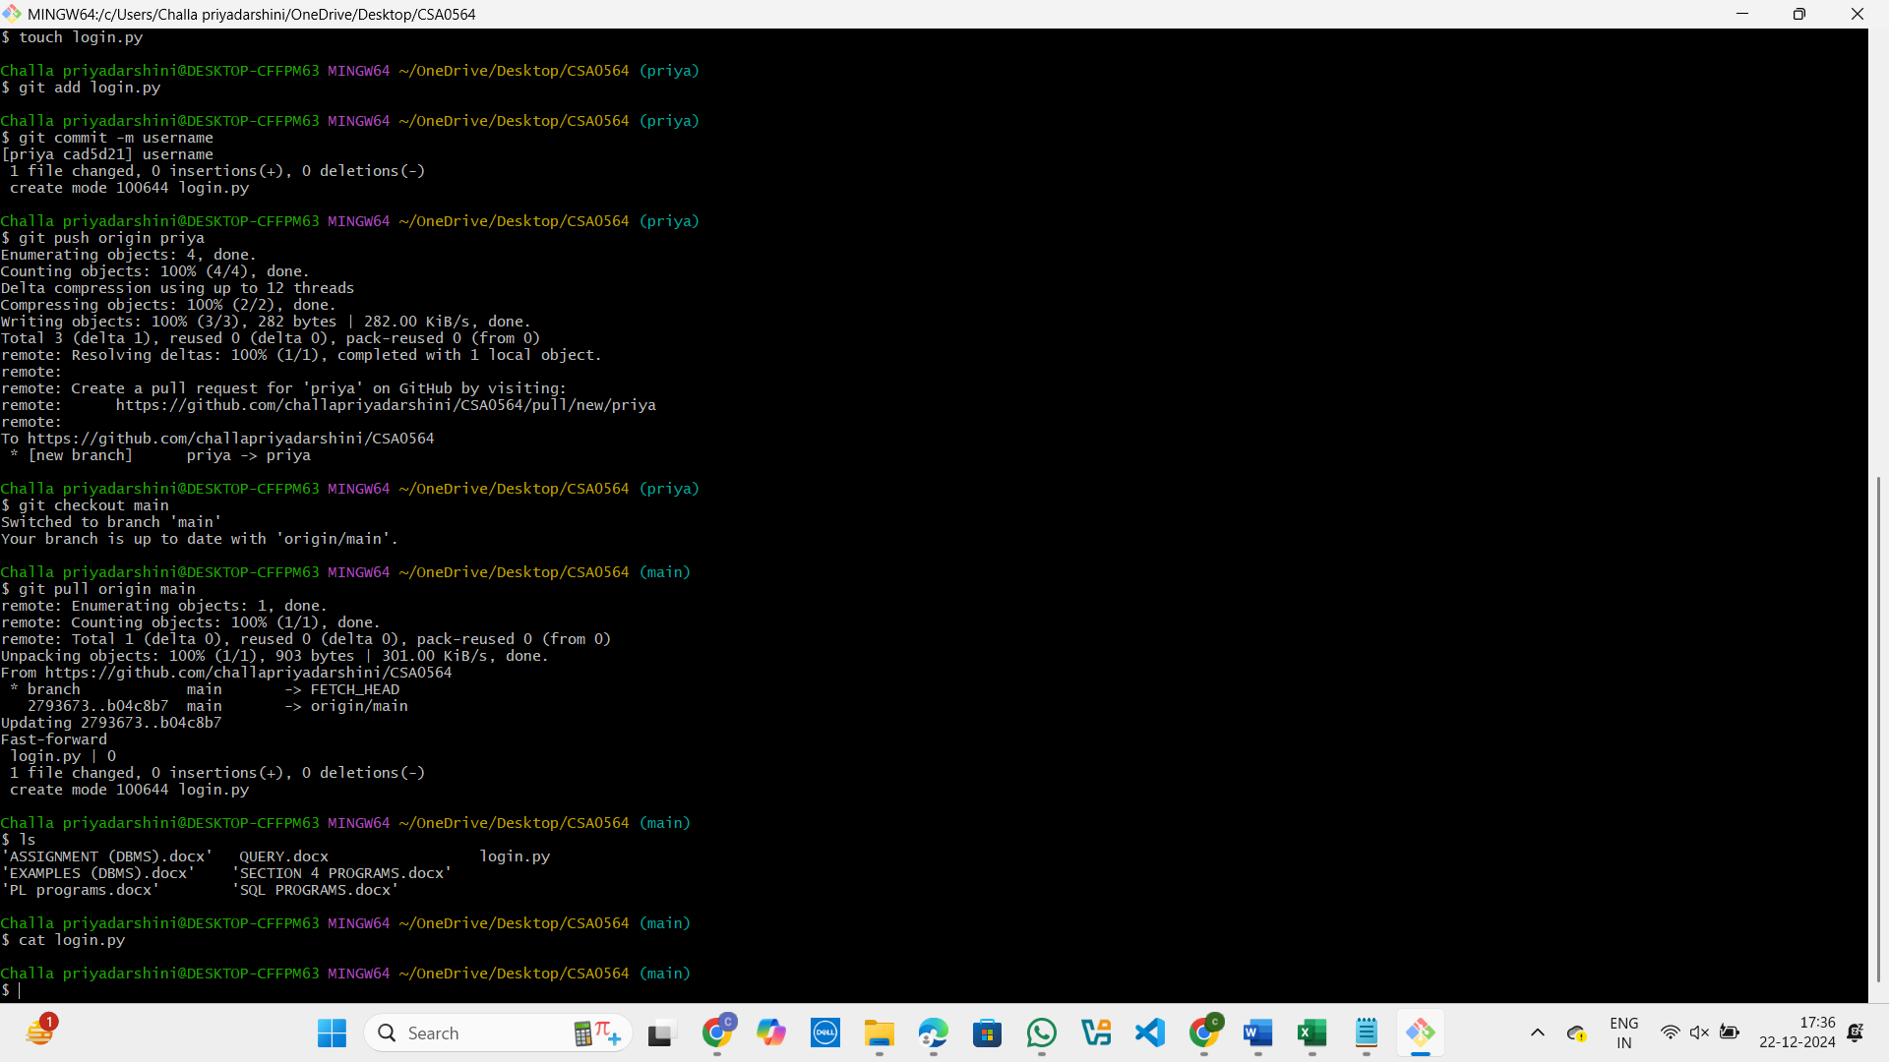

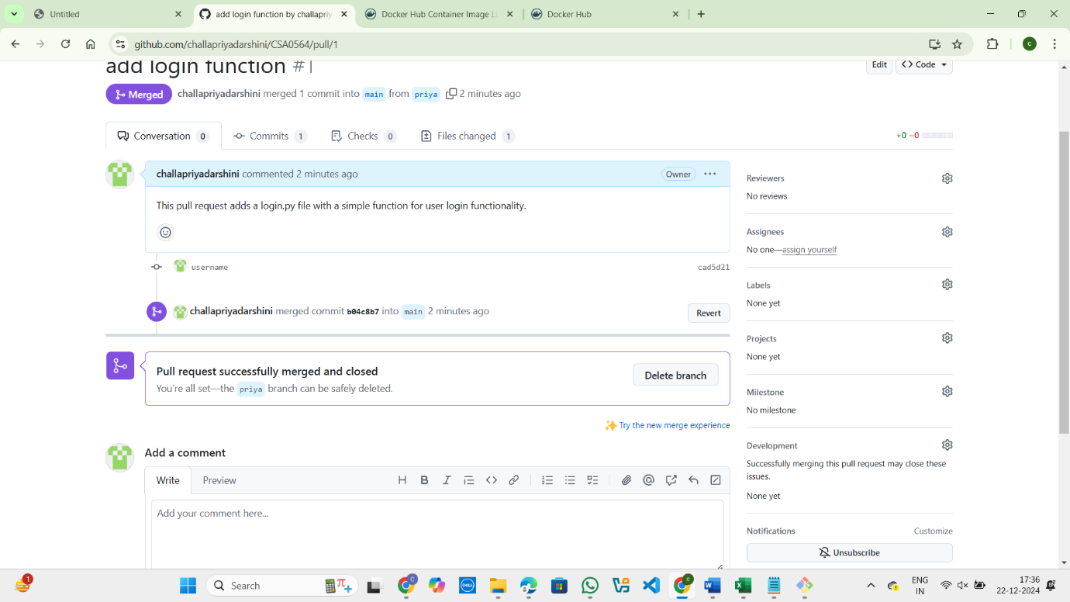

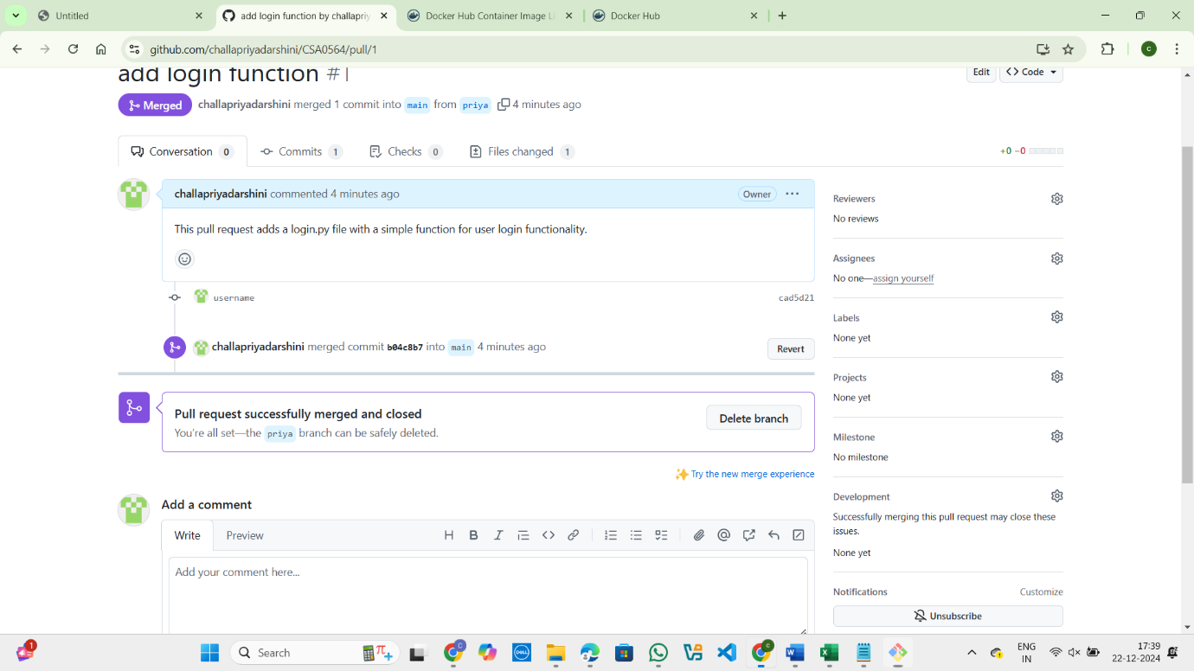

EXP 21:

GIT/GITHUB:

Clone an existing GitHub repository to your local machine and make a small change in one of the files. Tasks:

• Choose an existing public GitHub repository (e.g., your own or a sample repository).

• Clone the repository to your local machine using git clone .

• Navigate into the cloned repository directory and open one of the files.

• Make a small edit, such as modifying a line of text or fixing a typo.

• Save your changes.

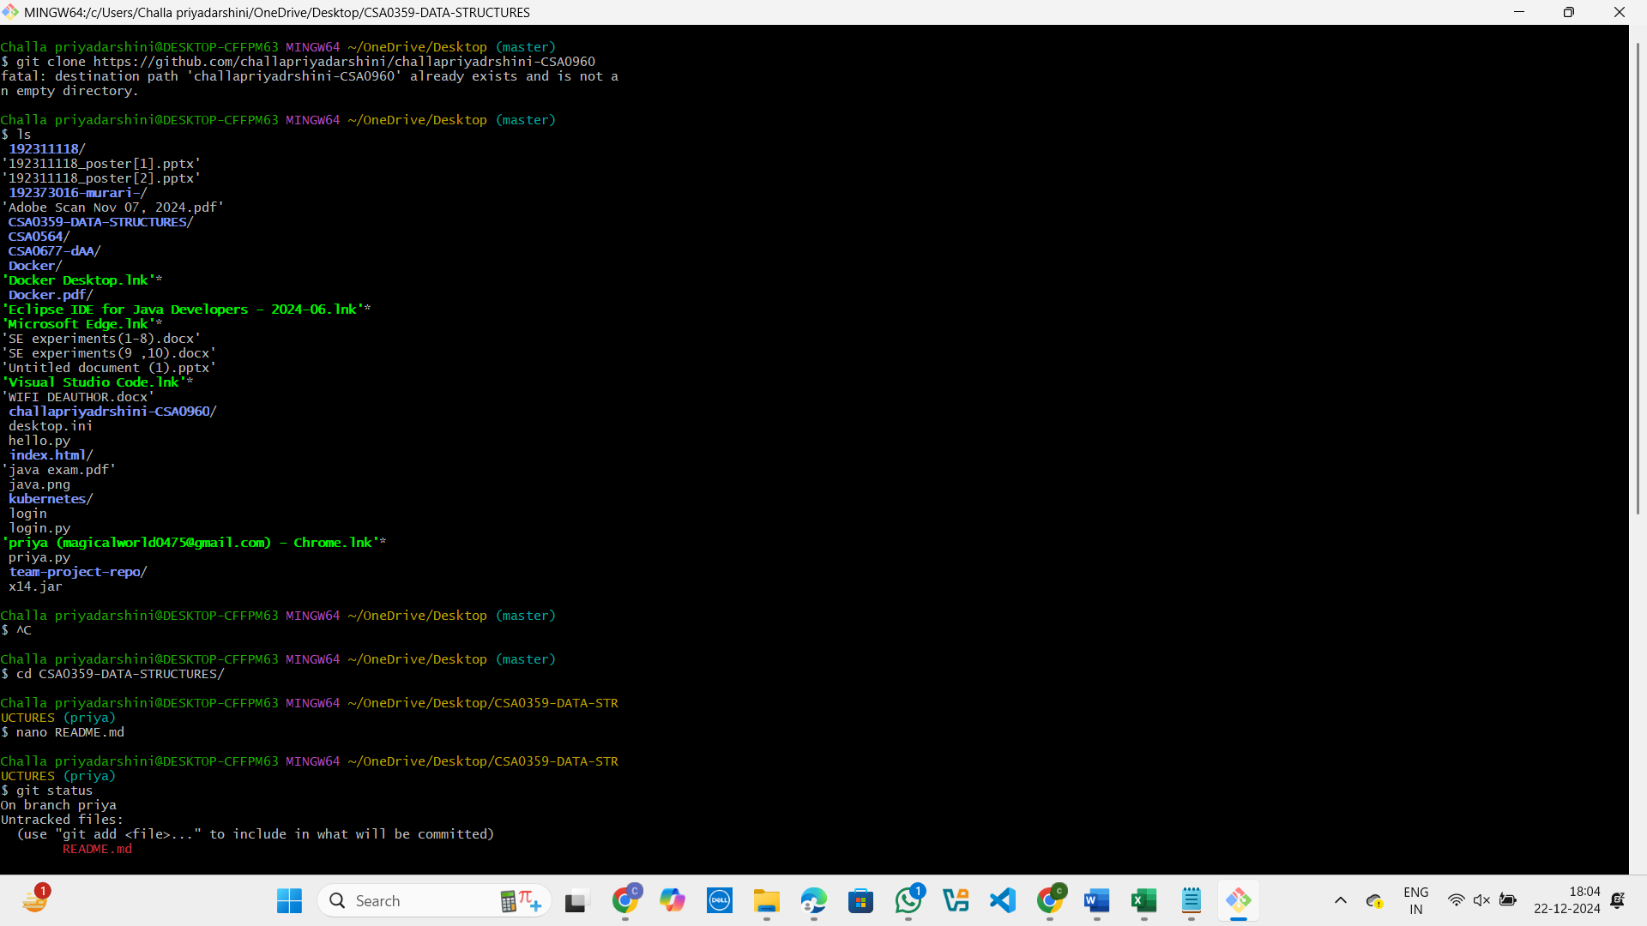

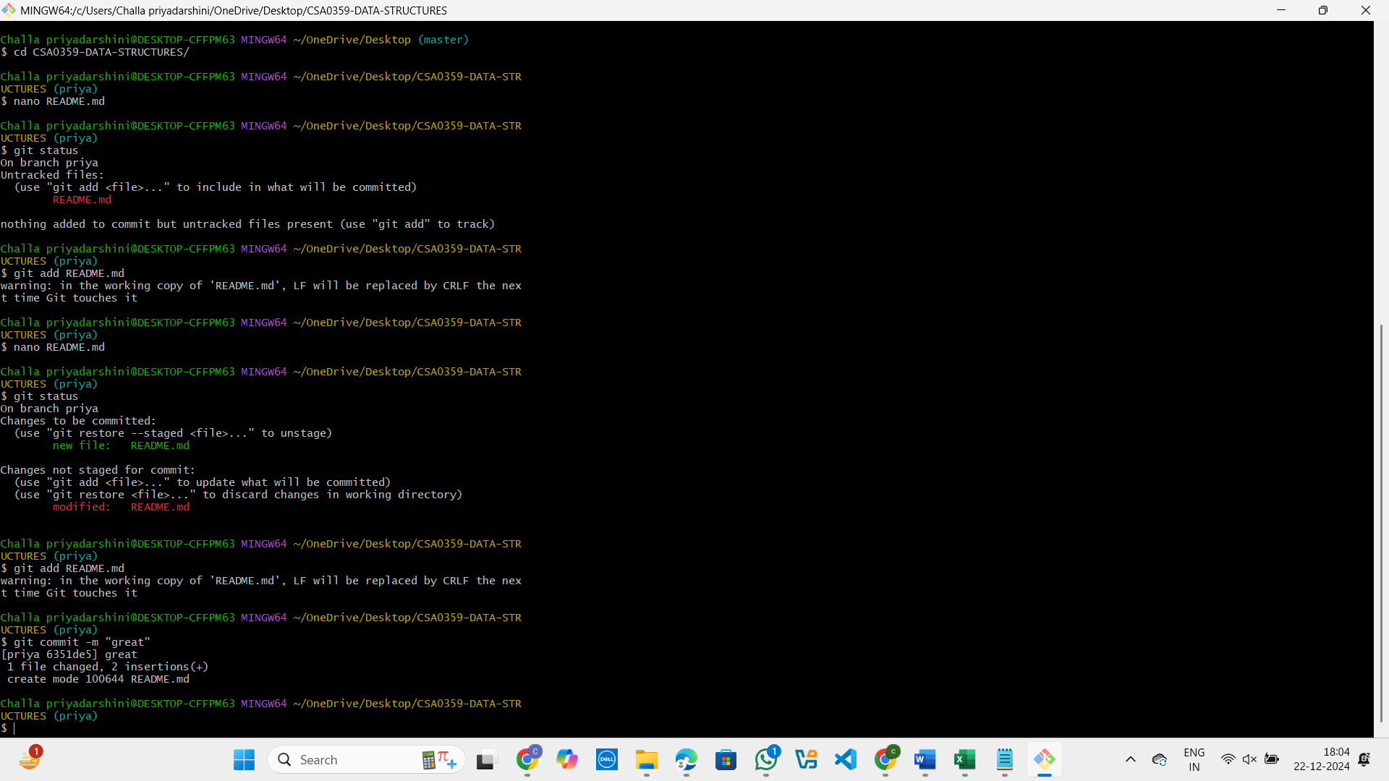

EXP 25:

GIT/GITHUB:

